Chapter 1

**Introduction to JavaScript**

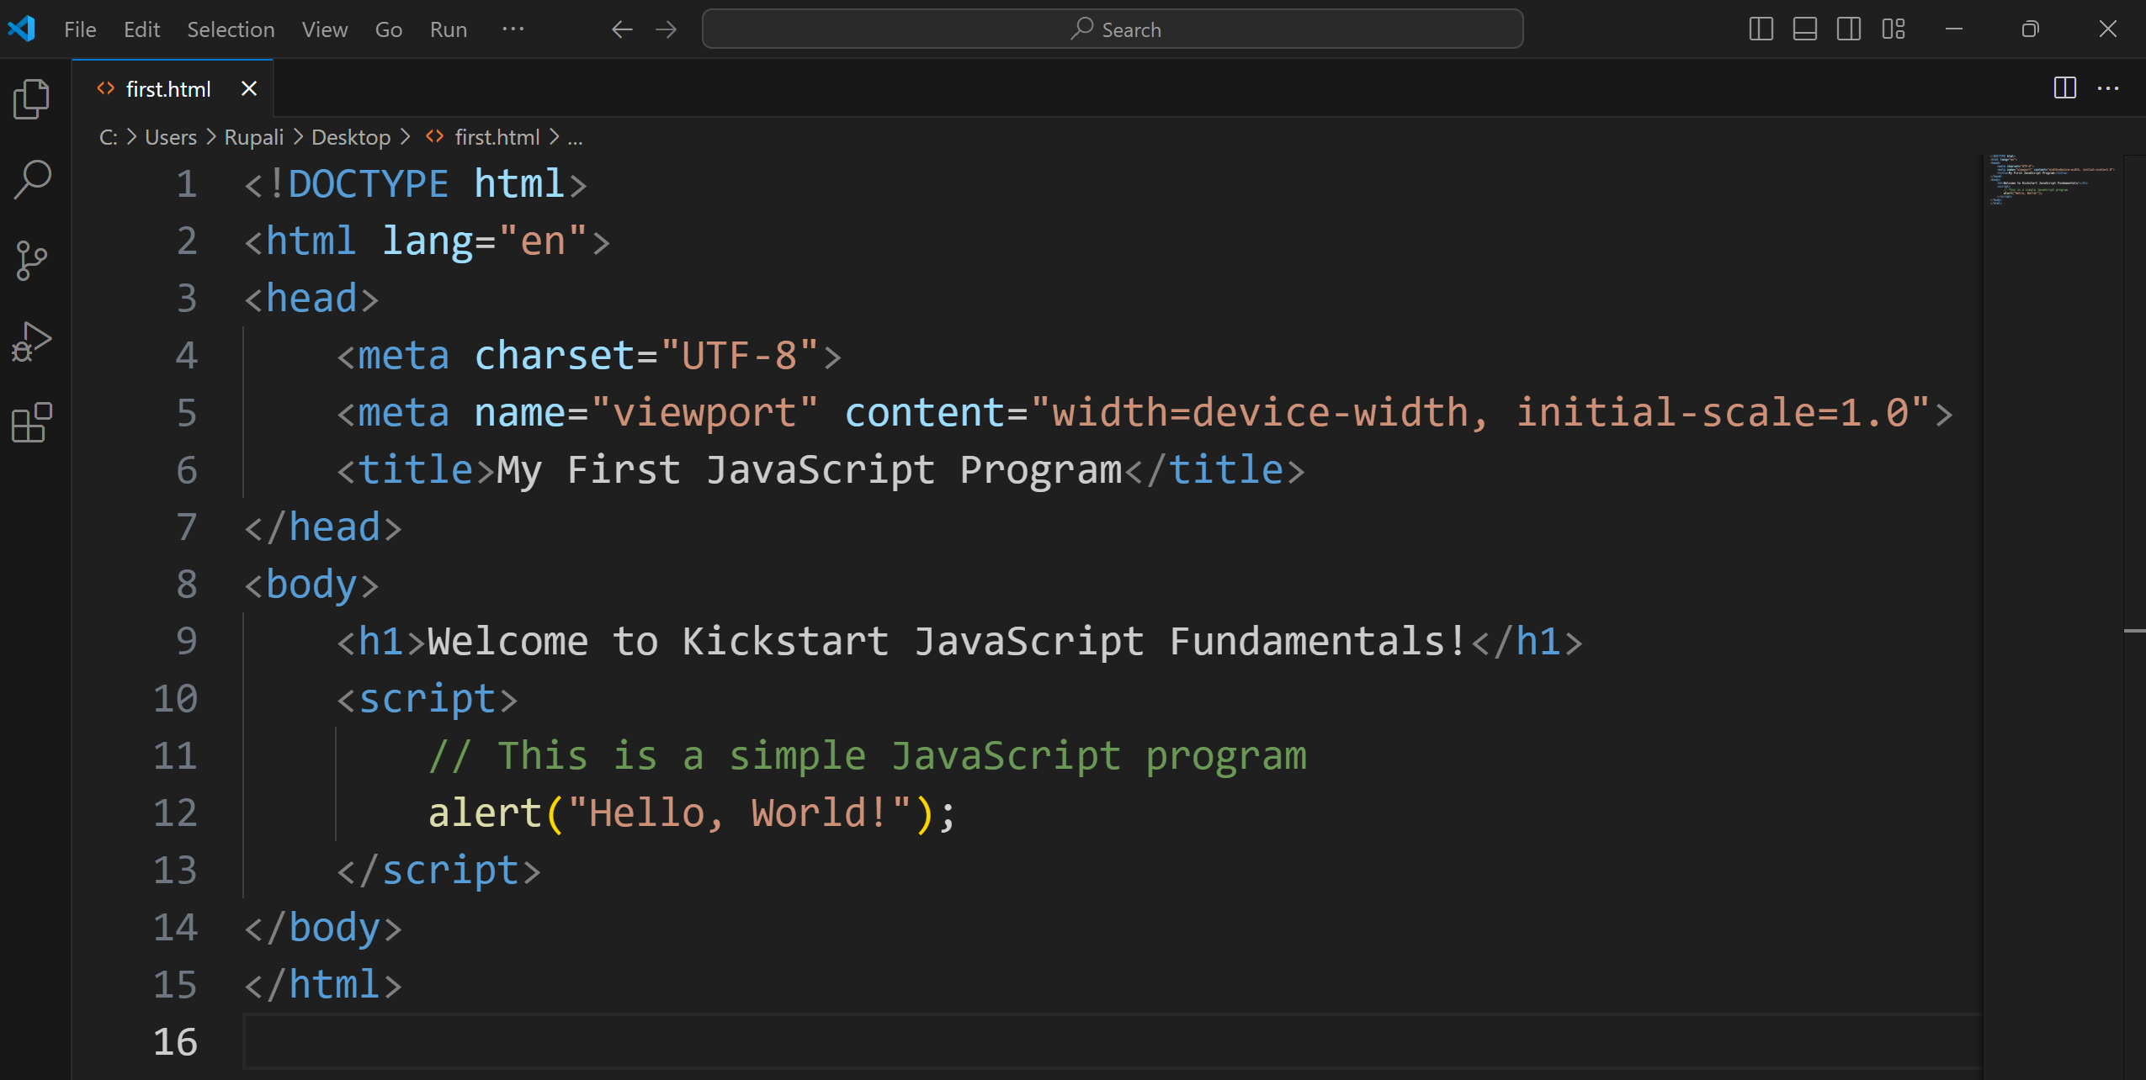

*Figure 1.3: first.html file with JavaScript Code*

Code to log a message to the console instead of showing an alert.

<!DOCTYPE html>

<html lang="en">

<head>

<meta charset="UTF-8">

<meta name="viewport" content="width=device-width, initial-scale=1.0">

<title>JavaScript Console Example</title>

</head>

<body>

<h1>Check the Console!</h1>

<script>

// Logging a message to the console

console.log("This is a message printed to the console!");

</script>

</body>

</html>

1. Logging to the Console:

Replace alert("Hello, World!"); with:

console.log("Hello, World!");

1. Writing to the Webpage:

Replace alert("Hello, World!"); with:

document.write("Hello, World!");

1. Combining Outputs:

Use multiple commands:

alert("Hello, World!");

console.log("This is logged in the console.");

document.write("This is written on the webpage.");

Example: Impact of Formatting on Readability Without new lines or indentation

let age = 20; let adult = true; if (age >= 18) { console.log("You are an adult."); if (adult) { console.log("You can vote!"); } else { console.log("You still have time to enjoy your youth!"); } } else { console.log("You are not an adult yet."); }

Example: With new lines but without indentation

let age = 20;

let adult = true;

if (age >= 18) {

console.log("You are an adult.");

if (adult) {

console.log("You can vote!");

} else {

console.log("You still have time to enjoy your youth!");

}

} else {

console.log("You are not an adult yet.");

}

Example: With new lines and proper indentation

let age = 20;

let adult = true;

if (age >= 18) {

console.log("You are an adult.");

if (adult) {

console.log("You can vote!");

} else {

console.log("You still have time to enjoy your youth!");

}

} else {

console.log("You are not an adult yet.");

}

// This is a single-line comment

let name = "Rupali"; // This declares a variable called 'name'

console.log(name); // Logs 'Rupali' to the console

/*

This is a multi-line comment.

It can span multiple lines and is useful for:

1. Explaining complex code logic.

2. Temporarily disabling large blocks of code.

*/

let age = 25; // Declaring a variable

console.log(age); // Logs '25' to the console

Example:

// Calculate the area of a rectangle

let length = 10;

let width = 5;

let area = length * width; // Formula for area

console.log(area); // Logs '50'

Example:

let x = 20;

// console.log(x); // Temporarily disabled for testing

Example:

// Check if a number is even or odd

let number = 11;

if (number % 2 === 0)

{

console.log("Even"); // Executes if the number is even

} else

{

console.log("Odd"); // Executes if the number is odd

}